Ships & Towers
Ships and Towers are two types of 5★ dungeons found in the Sundered Uplands biome in Difficulty 13 and 14 Prime worlds.
While they function similarly, they are used for different purposes:

🚢 Ships (D13 XP Farming)
Ships are primarily used for experience farming and are typically run in Difficulty 13.
They function as a wave-based dungeon, where players stay in assigned rooms to continuously spawn enemies and gain XP.
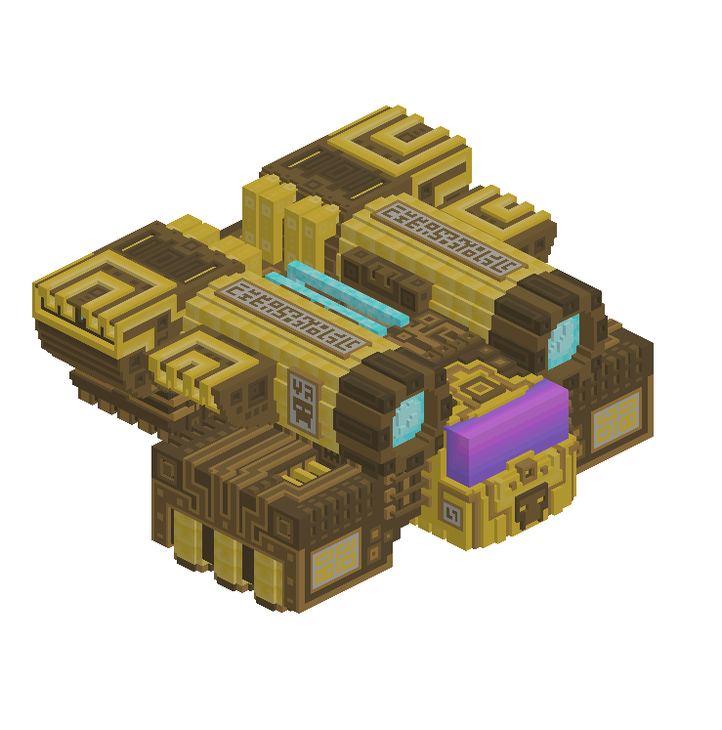

Objective
Push to the highest wave as quickly as possible.
With the current max Light (~13,973 as of 5/1/2026), players can realistically reach around wave 100.

Requirements
- 6 players:
  - 5 players covering individual rooms
  - 1 player handling the boss room
- 1 reset player to activate the console after each wave
(Rooms = separate sections of the ship where enemies spawn independently.)

Optimization
- Use a runner or alt to locate the next ship while the current one is being completed
- Minimize downtime between ships to maximize XP/hour

🏰 Towers (D14 Phoenix Motes Farming)
Towers are primarily used for farming Phoenix Motes, a key crafting resource in the Sundered Uplands crafting bench.
They are typically run in Difficulty 14, where waves are harder and shorter.
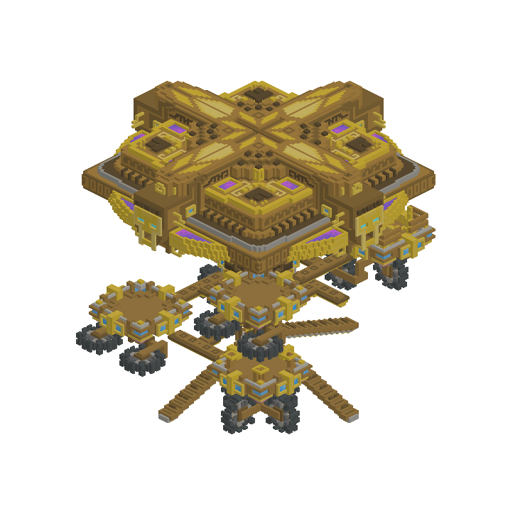

Objective
Farm Phoenix Motes, which:
- Commonly drop from the boss
- Occasionally drop from mini-bosses

Requirements
- 1 or more players with 12,500+ Light

Optimization
- Assign players to specific rooms once the tower begins
- Each player repeatedly clears their assigned room
- Return to the boss room on boss waves
- A dedicated reset player improves efficiency significantly
- Limit players in the farm to <8 to maximize phoenix mote drop rates

